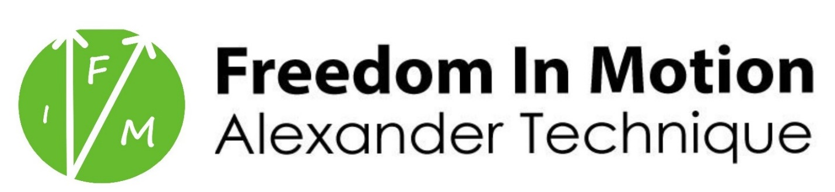
ONLINE POLICIES & PROCEDURES

Welcome! I am excited for us to work together. Below are policies and information important for you to know going into your first lesson. Having clarity on these points will help us to get the most out of our sessions. Please sign the document electronically at the bottom of the last page and email it to freedominmotionat@gmail.com

- All sessions will take place online via Zoom. No app is required to join the meeting unless you are calling from a mobile device, though you might find downloading the app improves your experience. Links to the conference are included in your confirmation by clicking “lesson location”. If there are any problems getting online at the lesson time, please call or text me on my cell phone at 630-863-9560.
- Sessions will last for the length of the booked appointment. Any extra time will be added at the sole discretion of the instructor. Please be on time for the start of your lesson. If you are running late, please send a text to my cell phone so I know when to expect you. You are welcome to log into the conference up to five minutes before your scheduled time to get settled and ready to begin. You may be let into the conference early depending on if there is another appointment directly prior to yours.
- Payment is made when booking your appointment or purchasing a package online via credit or debit card or using Venmo (@ ‘JeremyCohnAT’) or another electronic transfer method prior to the session beginning. Payment must be received before a session will take place. There are no refunds for lessons purchased as part of a package once the first lesson of a package has taken place.
- If you must cancel or reschedule a lesson, please give at least 24-hour’s notice and reschedule via the online scheduler (accessible from your confirmation email). Lesson fees for lessons not cancelled or rescheduled before that period are forfeit (except in case of emergency as determined by instructor discretion).
- The Alexander Technique is an educational method that can have therapeutic benefits. It is important to understand that it is not a substitute for treatment from a medical or psychological professional. If you have a serious medical condition, make sure to consult with a doctor prior to your first visit. There is no reason to expect adverse physical effects from the sessions, but if you experience pain or serious discomfort during a lesson please make sure to inform the instructor immediately. Freedom In Motion is not responsible for any change in your health you experience during or following enrollment in any of our programs.
- You are welcome to record lessons for personal review—the instructor will ask if you would like to record at the beginning of your session. These recordings are considered private and may not be shared with anyone outside of the participants of the session without written permission of all involved. All information given by the student in lessons and correspondence will be treated as confidential.
- There is no need for athletic apparel for sessions, but please wear clothing that is not overly restrictive so you are free to move.
- Rates are subject to change with notice. Packages purchased before the date of rate change will be honored. Packages are redeemable for up to six months from original purchase date.

Don’t hesitate to write if you have questions on any of these policies and procedures. Please sign and date electronically below to acknowledge you have read and understand all of the above. I am looking forward to working with you!

____________________ _______________
STUDENT SIGNATURE DATE

